
CS361 – Web Programming
Campus Events Hub
Individual Completed Work and Technical Solution
Student Name | Nawaf Aldossari
Student ID | S230006942
Assigned Role | Shared CSS, Responsive Design, Registrations List, About/Contact Page, and Final Testing
Project | Campus Events Hub
This file contains the completed implementation corresponding to the tasks assigned to this student in the submitted project records.
1. Assigned Tasks
Week | Date | Task as Recorded
Week 1 | 15/07/2026 | Prepared the initial color scheme and page-layout ideas.
Week 2 | 22/07/2026 | Developed the shared CSS file and adjusted the layout for different screen sizes.
Week 3 | 29/07/2026 | Reviewed the event data and checked the page styling after the database connection.
Week 4 | 05/08/2026 | Developed the Registrations List table and improved its mobile responsiveness.
Week 5 | 09/08/2026 | Completed the About/Contact page, performed responsive-design testing, and organized the final project folder.
2. Completed Solution
- Established the shared visual system through CSS variables for colors, borders, shadows, and spacing.
- Styled the navigation, page banners, cards, forms, validation messages, tables, and footer.
- Added responsive breakpoints for tablets and mobile screens, including stacked layouts and flexible navigation.
- Built the Registrations List page using an SQL JOIN to show each student with the related event title.
- Escaped stored registration values before displaying them in the HTML table.
- Completed the About/Contact page and implemented validation for required fields, email format, and message length.
3. Visual Evidence
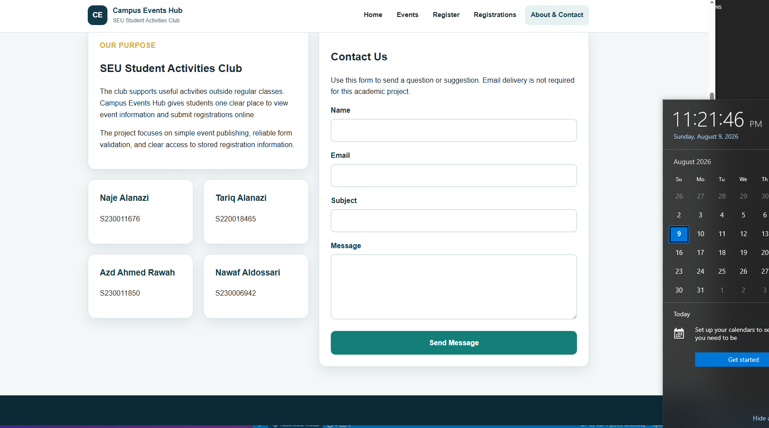
Completed About/Contact page with the project team and validated contact form.
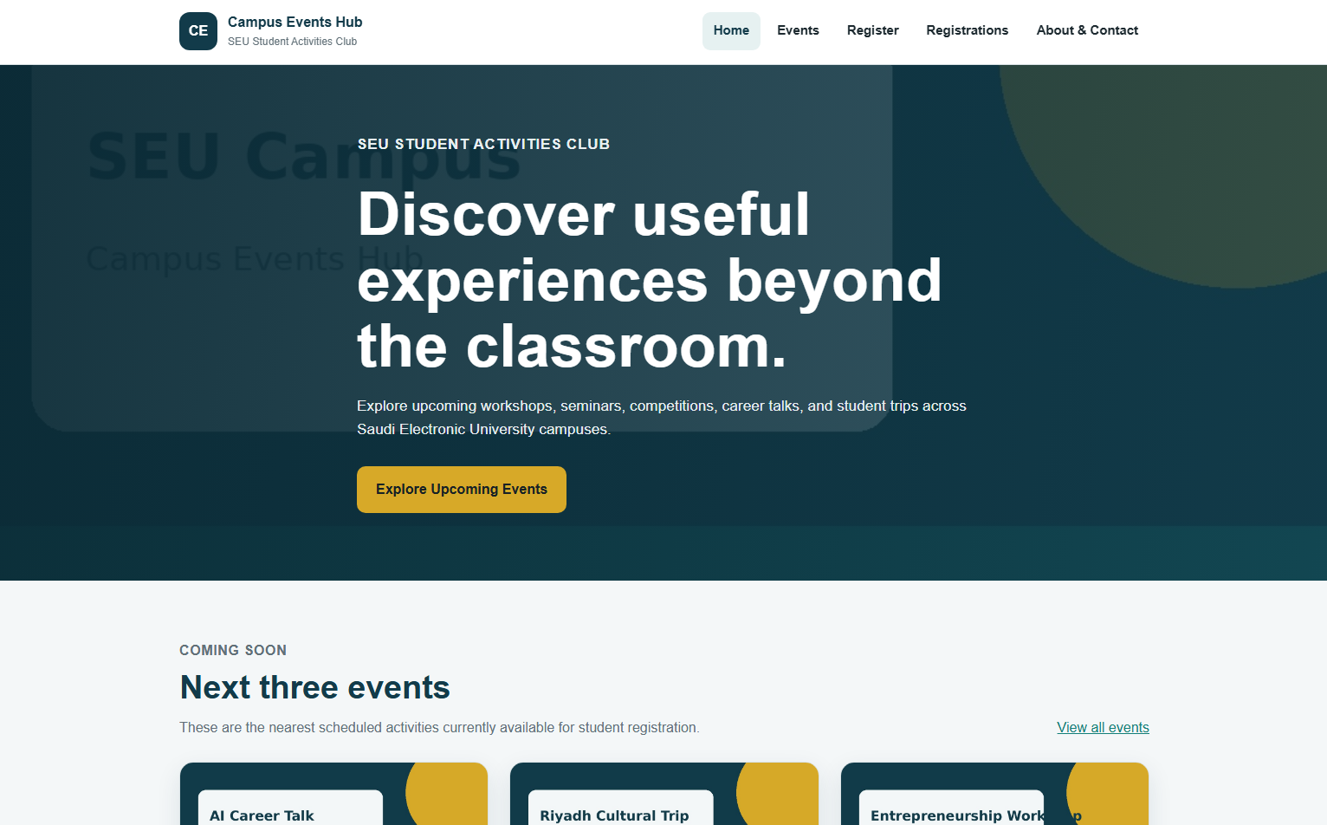
Consistent responsive visual design applied across the website.
4. Verification Results
Test | Expected / Recorded Result | Status
View pages above 900 px | Three-column and two-column layouts appear as designed. | Pass
View pages below 900 px | Event grids reduce to two columns and detail/about layouts stack. | Pass
View pages below 620 px | Forms, team cards, footer, and navigation use one-column mobile layouts. | Pass
Open registrations.php with records | The joined registration table appears and remains horizontally scrollable. | Pass
Submit invalid contact data | Required, email, or message-length errors appear. | Pass
Submit valid contact data | The success message appears and fields are cleared. | Pass

5. Relevant Source-Code Solution
The following code is taken from the submitted project source files and corresponds directly to the student's assigned implementation.
registrations.php
<?php
require_once 'includes/db.php';
$pageTitle = 'Registrations';
$sql = "SELECT registrations.*, events.title AS event_title
FROM registrations
JOIN events ON registrations.event_id = events.id
ORDER BY registrations.registration_date DESC";
$registrationsResult = mysqli_query($conn, $sql);
require_once 'includes/header.php';
?>
<section class="page-banner">
<div class="container">
<h1>Registrations List</h1>
<p>This table displays the student registrations currently stored in the project database.</p>
</div>
</section>
<section class="section">
<div class="container">
<?php if ($registrationsResult && mysqli_num_rows($registrationsResult) > 0): ?>
<div class="table-wrapper">
<table>
<thead>
<tr>
<th scope="col">Student Name</th>
<th scope="col">Student ID</th>
<th scope="col">Email</th>
<th scope="col">Event</th>
<th scope="col">Registration Date</th>
</tr>
</thead>
<tbody>
<?php while ($registration = mysqli_fetch_assoc($registrationsResult)): ?>
<tr>
<td><?php echo htmlspecialchars($registration['student_name']); ?></td>
<td><?php echo htmlspecialchars($registration['student_id']); ?></td>
<td><?php echo htmlspecialchars($registration['email']); ?></td>
<td><?php echo htmlspecialchars($registration['event_title']); ?></td>
<td><?php echo date('d M Y, g:i A', strtotime($registration['registration_date'])); ?></td>
</tr>
<?php endwhile; ?>
</tbody>
</table>
</div>
<?php else: ?>
<div class="empty-state">
<h2>No registrations yet</h2>
<p>Completed student registrations will appear on this page.</p>
<a class="button" href="register.php">Open Registration Form</a>
</div>
<?php endif; ?>
</div>
</section>
<?php require_once 'includes/footer.php'; ?>

about.php
<?php
$pageTitle = 'About and Contact';
$contactErrors = [];
$contactSuccess = '';
$name = '';
$email = '';
$subject = '';
$message = '';
if ($_SERVER['REQUEST_METHOD'] === 'POST') {
$name = trim($_POST['name'] ?? '');
$email = trim($_POST['email'] ?? '');
$subject = trim($_POST['subject'] ?? '');
$message = trim($_POST['message'] ?? '');
if ($name === '' || $email === '' || $subject === '' || $message === '') {
$contactErrors[] = 'All contact form fields are required.';
}
if ($email !== '' && !filter_var($email, FILTER_VALIDATE_EMAIL)) {
$contactErrors[] = 'Enter a valid email address.';
}
if ($message !== '' && mb_strlen($message) < 15) {
$contactErrors[] = 'The message must contain at least 15 characters.';
}
if (!$contactErrors) {
$contactSuccess = 'Thank you for contacting us. Your message has been received.';
$name = '';
$email = '';
$subject = '';
$message = '';
}
}
require_once 'includes/header.php';
?>
<section class="page-banner">
<div class="container">
<h1>About the Club</h1>
<p>Learn about the purpose of the website, meet the project team, and send a simple enquiry.</p>
</div>
</section>
<section class="section">
<div class="container about-grid">
<div>
<article class="info-card">
<p class="eyebrow">Our Purpose</p>
<h2>SEU Student Activities Club</h2>
<p>The club supports useful activities outside regular classes. Campus Events Hub gives students one clear place to view event information and submit registrations online.</p>
<p>The project focuses on simple event publishing, reliable form validation, and clear access to stored registration information.</p>
</article>
<div class="team-grid team-grid-spaced">
<article class="team-card">
<h3>Naje Alanazi</h3>
<p>S230011676</p>
</article>
<article class="team-card">
<h3>Tariq Alanazi</h3>
<p>S220018465</p>
</article>
<article class="team-card">
<h3>Azd Ahmed Rawah</h3>
<p>S230011850</p>
</article>
<article class="team-card">
<h3>Nawaf Aldossari</h3>
<p>S230006942</p>
</article>
</div>
</div>
<div class="form-card">
<h2>Contact Us</h2>
<p>Use this form to send a question or suggestion. Email delivery is not required for this academic project.</p>
<?php if ($contactErrors): ?>
<div class="message message-error" role="alert">
<ul>
<?php foreach ($contactErrors as $error): ?>
<li><?php echo htmlspecialchars($error); ?></li>
<?php endforeach; ?>
</ul>
</div>
<?php endif; ?>
<?php if ($contactSuccess): ?>
<div class="message message-success" role="status">
<?php echo htmlspecialchars($contactSuccess); ?>
</div>
<?php endif; ?>
<form action="about.php" method="post" novalidate>
<div>
<label for="name">Name</label>
<input type="text" id="name" name="name" value="<?php echo htmlspecialchars($name); ?>" required maxlength="120">
</div>
<div>
<label for="contact_email">Email</label>
<input type="email" id="contact_email" name="email" value="<?php echo htmlspecialchars($email); ?>" required maxlength="160">
</div>
<div>
<label for="subject">Subject</label>
<input type="text" id="subject" name="subject" value="<?php echo htmlspecialchars($subject); ?>" required maxlength="160">
</div>
<div>
<label for="message">Message</label>
<textarea id="message" name="message" required maxlength="1000"><?php echo htmlspecialchars($message); ?></textarea>
</div>
<button class="button" type="submit">Send Message</button>
</form>
</div>
</div>
</section>
<?php require_once 'includes/footer.php'; ?>

css/style.css – assigned implementation sections
:root {
--primary: #123b4a;
--primary-dark: #0b2a35;
--secondary: #137f78;
--accent: #d7a928;
--surface: #ffffff;
--background: #f4f7f8;
--text: #1d2a30;
--muted: #617078;
--border: #d9e2e5;
--success: #176b45;
--success-bg: #e8f6ef;
--danger: #a12c2c;
--danger-bg: #fff0f0;
--shadow: 0 10px 28px rgba(18, 59, 74, 0.10);
--radius: 16px;
}
* {
box-sizing: border-box;
}
html {
scroll-behavior: smooth;
}
body {
margin: 0;
font-family: Arial, Helvetica, sans-serif;
color: var(--text);
background: var(--background);
line-height: 1.6;
}
img {
max-width: 100%;
display: block;
}
a {
color: var(--secondary);
}
.container {
width: min(1120px, 92%);
margin: 0 auto;
}
.site-header {
position: sticky;
top: 0;
z-index: 20;
background: rgba(255, 255, 255, 0.97);
border-bottom: 1px solid var(--border);
}
.nav-wrapper {
min-height: 76px;
display: flex;
align-items: center;
justify-content: space-between;
gap: 24px;
}
.brand {
display: flex;
align-items: center;
gap: 12px;
color: var(--primary);
text-decoration: none;
}
.brand-mark {
width: 44px;
height: 44px;
display: grid;
place-items: center;
border-radius: 12px;
color: white;
background: var(--primary);
font-weight: 700;
}
.brand strong,
.brand small {
display: block;
}
.brand small {
color: var(--muted);
font-size: 0.76rem;
}
.main-nav ul {
display: flex;
flex-wrap: wrap;
gap: 6px;
list-style: none;
margin: 0;
padding: 0;
}
.main-nav a {
display: block;
padding: 10px 13px;
border-radius: 9px;
color: var(--text);
text-decoration: none;
font-weight: 700;
font-size: 0.93rem;
}
.main-nav a:hover,
.main-nav a:focus-visible,
.main-nav a.active {
background: #e6f1f1;
color: var(--primary);
}
.hero {
padding: 78px 0;
color: white;
background:
linear-gradient(100deg, rgba(11, 42, 53, 0.96), rgba(18, 59, 74, 0.82)),
url('../images/university-campus.jpg') center/cover;
}
.hero-content {
max-width: 710px;
}
/* Additional assigned section */
.detail-layout {
display: grid;
grid-template-columns: 1.2fr 0.8fr;
gap: 28px;
align-items: start;
}
.detail-image {
width: 100%;
max-height: 430px;
object-fit: cover;
border-radius: var(--radius);
margin-bottom: 24px;
}
.detail-card h2 {
margin-top: 0;
color: var(--primary);
}
form {
display: grid;
gap: 18px;
}
.form-row {
display: grid;
grid-template-columns: 1fr 1fr;
gap: 18px;
}
label {
display: block;
margin-bottom: 6px;
color: var(--primary);
font-weight: 700;
}
input,
select,
textarea {
width: 100%;
padding: 12px 13px;
border: 1px solid #b9c8cd;
border-radius: 9px;
background: white;
color: var(--text);
font: inherit;
}
textarea {
min-height: 145px;
resize: vertical;
}
input:focus,
select:focus,
textarea:focus {
outline: 3px solid rgba(19, 127, 120, 0.18);
border-color: var(--secondary);
}
.message {
padding: 16px 18px;
margin-bottom: 22px;
border-radius: 10px;
border: 1px solid;
}
.message ul {
margin: 8px 0 0;
}
.message-error {
color: var(--danger);
background: var(--danger-bg);
border-color: #efbcbc;
}
.message-success {
color: var(--success);
background: var(--success-bg);
border-color: #b6dfca;
}
.table-wrapper {
overflow-x: auto;
background: white;
border: 1px solid var(--border);
border-radius: var(--radius);
box-shadow: var(--shadow);
}
table {
width: 100%;
border-collapse: collapse;
min-width: 800px;
}
th,
td {
padding: 15px;
border-bottom: 1px solid var(--border);
text-align: left;
}
th {
background: var(--primary);
color: white;
}
tbody tr:hover {
background: #f4f9f9;
}
.empty-state {
padding: 30px;
text-align: center;
background: white;
border: 1px dashed #aabdc3;
border-radius: var(--radius);
}
.team-grid {
grid-template-columns: repeat(2, 1fr);
}
.team-grid-spaced {
margin-top: 22px;
}
.about-grid {
grid-template-columns: 0.9fr 1.1fr;
}
.site-footer {
padding: 46px 0 18px;
color: #dce8eb;
background: var(--primary-dark);
}
.footer-grid {
display: grid;
grid-template-columns: 1fr 1fr;
gap: 30px;
}
.site-footer h2 {
color: white;
font-size: 1.1rem;
}
.site-footer p {
margin: 5px 0;
}
.copyright {
width: min(1120px, 92%);
margin: 32px auto 0;
padding-top: 18px;
border-top: 1px solid rgba(255,255,255,0.15);
text-align: center;
color: #b7c9ce;
font-size: 0.9rem;
}
@media (max-width: 900px) {
.nav-wrapper {
align-items: flex-start;
flex-direction: column;
padding: 14px 0;
}
.main-nav ul {
width: 100%;
}
.event-grid,
.benefit-grid {
grid-template-columns: repeat(2, 1fr);
}
.detail-layout,
.about-grid {
grid-template-columns: 1fr;
}
}
@media (max-width: 620px) {
.main-nav ul {
display: grid;
grid-template-columns: repeat(2, 1fr);
}
.main-nav a {
text-align: center;
}
.hero {
padding: 58px 0;
}
.section {
padding: 46px 0;
}
.event-grid,
.benefit-grid,
.team-grid,
.footer-grid,
.form-row {
grid-template-columns: 1fr;
}
.section-heading {
align-items: flex-start;
flex-direction: column;
}
}

